**IBM Data Science Capstone Project**

**Introduction**

A customer is looking to open a Chinese restaurant in Downtown Toronto, but cannot decide on which neighbourhood is best suited for this. The objective of this project is to help this customer determine which neighbourhood has the best potential for starting a Chinese restaurant.

**Data**

The data required for this problem are:

* Geo-data of Neighbourhood centers in Toronto (Latitude, Longitudes)
* Food places in various neighbourhood in Toronto
* Other venues in various neighbourhood in Toronto

Food places and other venues are searched for within 500m from the various neighbourhood centres in Toronto

The following data sources are to get the data required for this project

* Wikipedia Page on Toronto Neighbourhoods
* Pre-existing dataset to obtain Toronto Neighbourhood geo-location data (latitude and longitudes)
* Foursquare API to obtain venue data

**Methodology and Results**

**Exploratory Data Analysis**

Visualisation of the various neighbourhoods on the map was conducted as the initial exploration of the data set to analyse to understand where the various neighbourhoods for Downtown Toronto are located at. We can observe that within Downtown Toronto, there is an airport, a university as well as multiple parks. Downtown Toronto is also very near the coast.

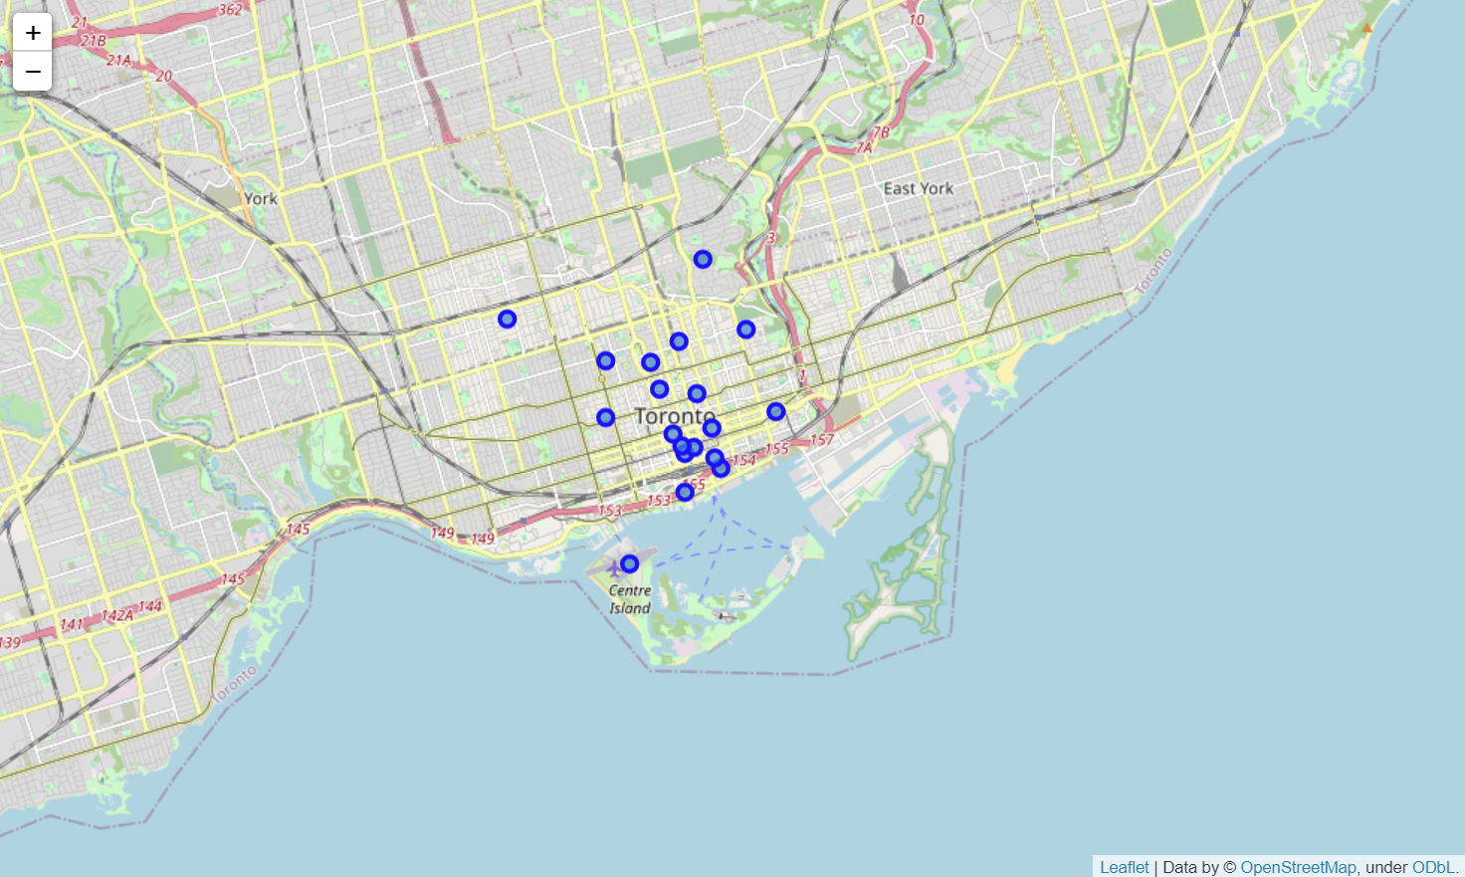

Since the objective is to help our client determine which area in Downtown Toronto is suitable for setting up a new Chinese/ Asian restaurant, we also want to find out where the restaurants are located at, and specifically, where the Chinese/ Asian restaurants are located at.

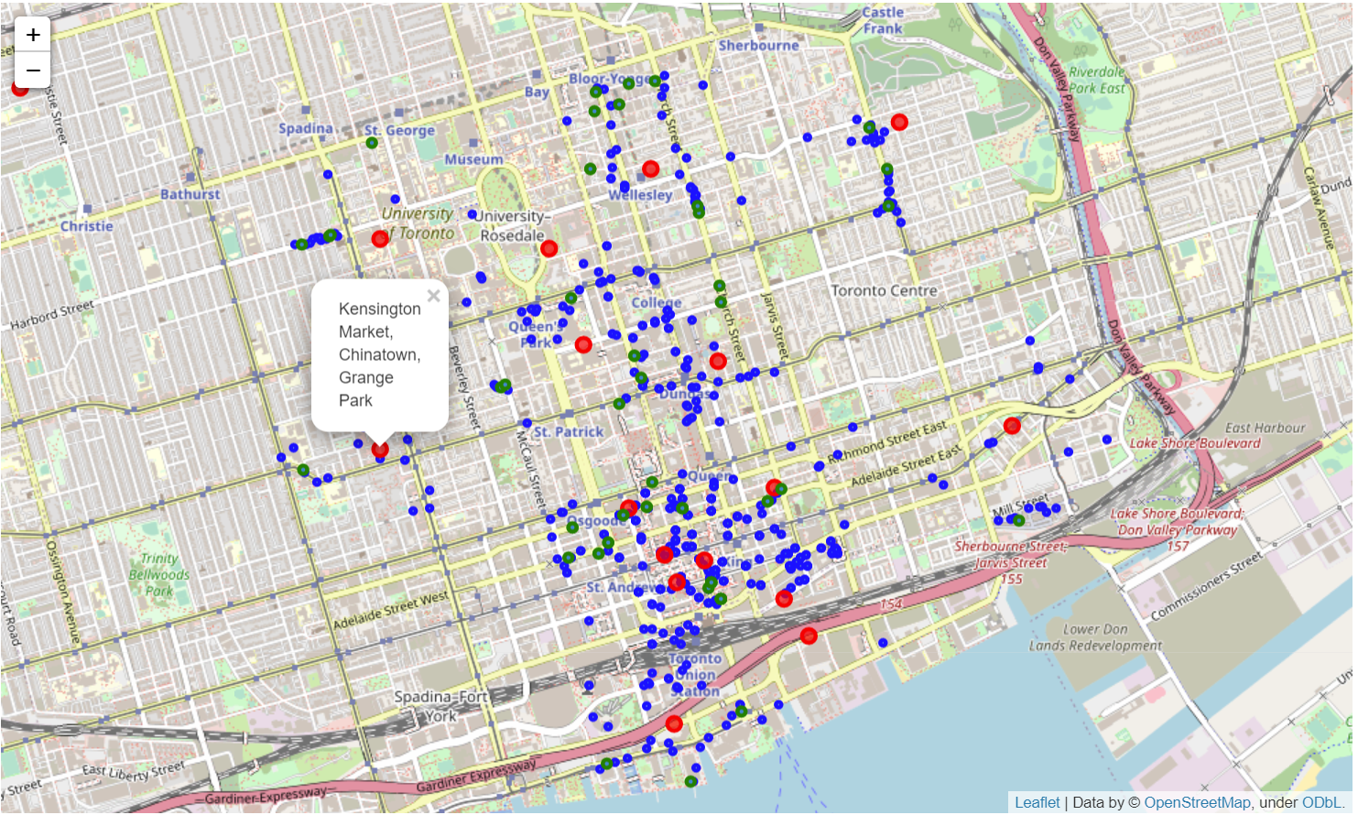

From the map above, we can see that the restaurants (blue) usually exists in a tight cluster and the Asian/ Chinese restaurants (green) are not a big phenomenon in Downtown Toronto. We observed that the Kensington area seems the most suitable as it has a dense cluster of restaurants, which brings about locality effect, but also has the lack of presence of an Asian/ Chinese restaurant which reduces direct competition if our client were to set up one in that area.

**Machine Learning (k clustering)**

We also want to determine how similar the various neighbourhoods are to each other in terms of amenities and facilities as a prediction of the lifestyle and habits of the habitants. This will be our predictor to whether an Asian/ Chinese restaurant is suitable for the neighbourhood.

We use the k clustering algorithm on the top 10 most common facilities in the neighbourhood, and the results are shown as below. As there are only 18 neighbourhoods in Downtown Toronto, the number of clusters we chose is only 5. We do not want the case where too many clusters or too little clusters are formed and not much information is observed.

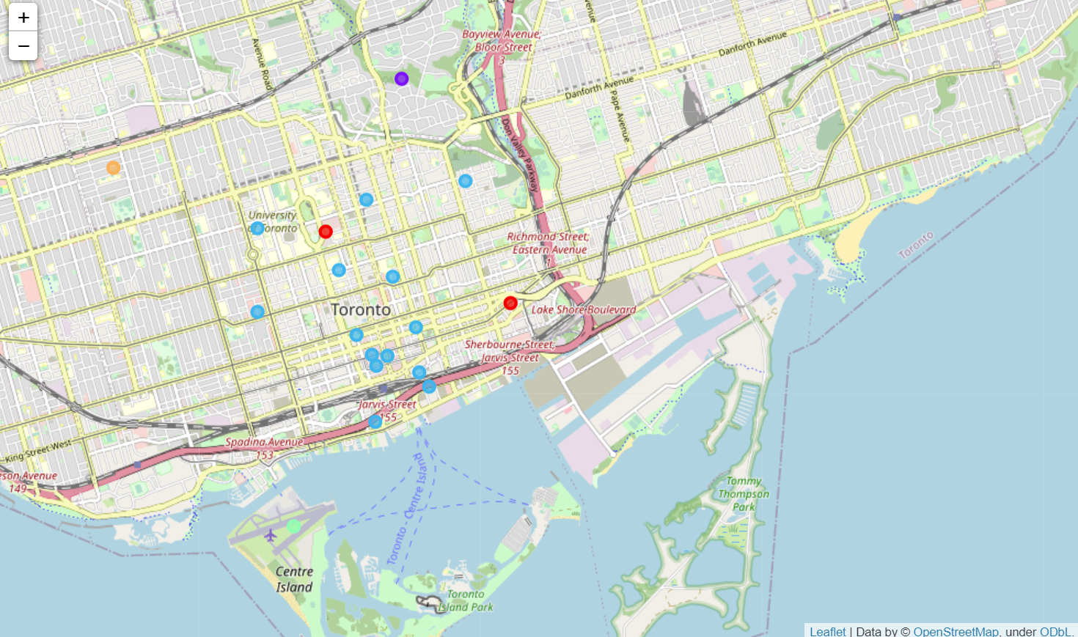

We can see that the Kensington neighbourhood is clustered together with other neighbourhoods such as the Richmond Area where there are many Chinese/ Asian restaurants. The close similarity in amenities in these neighbourhood signifies the similarity in lifestyle and habits.

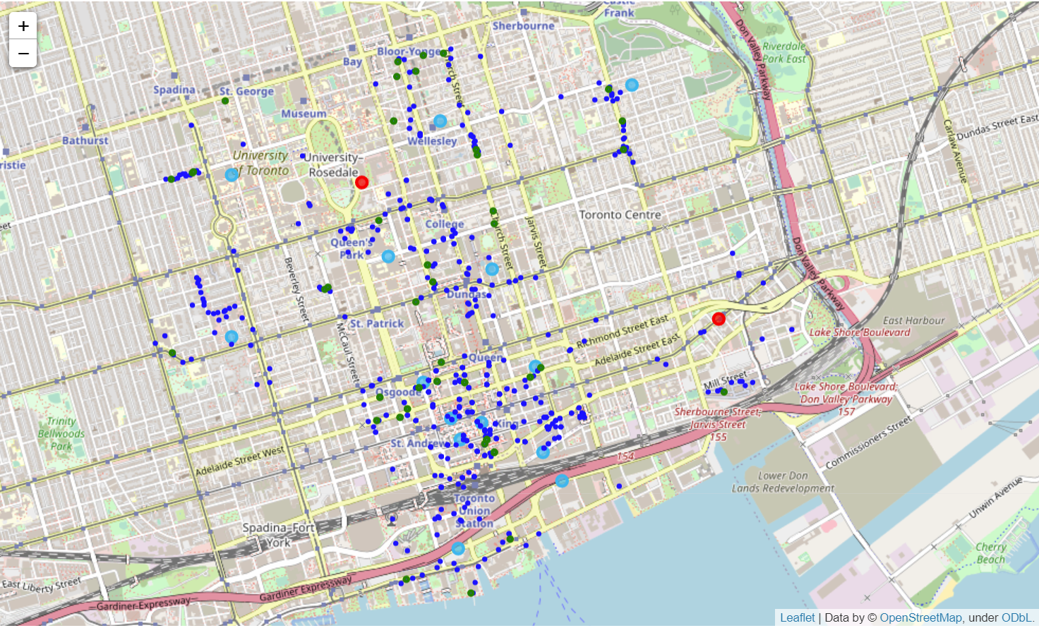

This map shows the various clusters (big circles) as well as the restaurants (dark blue) and Asian restaurants (green).

**Conclusion**

Our analysis shows that Downtown Toronto has over 600 restaurants and food related joints. From the map visualisations, we can also observe that food joints tend to cluster around certain regions. The highest concentration of restaurants was detected in the Southern side of Downtown Toronto. Although, starting a restaurant in this area is beneficial due to the locality of being near downtown where there is high density of human traffic, there also exists many Chinese/ Asian restaurants which makes it very competitive and may not be advantageous for our customer.

One interesting neighbourhood that was observed is the Kensington Market. It has a very dense cluster of restaurants in the vicinity, but only exists 1 Chinese/ Asian restaurant. Further analysis through k-clustering shows that the profile of amenities and facilities in the Kensington are very similar to those of the Southern region of Toronto. The similarity in profile of amenities is a signal that the lifestyle habits of the habitants are similar, and we would expect that they should also demonstrate some similarity towards food preferences.

The presence of food cluster and the lack of presence of Chinese/ Asian food creates a compelling environment for a new business in Chinese/ Asian food in the neighbourhood. The similarity of amenities and facilities between Kensington and the Southern area of Toronto could also be a signal that more Asian/ Chinese cuisine in Kensington would be appreciated as the Southern areas has many Asian/ Chinese joints.

We would recommend our client to set up a Chinese/ Asian food joint to the north-eastern area (red circle) of the Kensington neighbourhood where he can benefit from the locality effect of the clusters of food joints in the area, but also reduce competition from the Chinese food restaurant that is near the south-western area of the Kensington neighbourhood.

